Assignment – 5
Minmax Algorithm for game playing

Problem Statement:
The Minimax algorithm is a decision-making algorithm used for minimizing the possible loss for a worst-case scenario while maximizing the potential gain. It is primarily applied in two-player games like Tic-Tac-Toe, Chess, and Connect Four, where one player aims to maximize their score while the other tries to minimize it. The objective of this assignment is to implement the Minimax algorithm to determine the best possible move for a player in a two-player game.

Software used:
- Python 3.x
- Google Colab

Libraries and packages used:
- NumPy: For managing the game board in array format.
- Matplotlib: For visualizing the game board

Theory:
The Minimax algorithm works by recursively exploring the game tree of possible moves and counter-moves. Each node in the tree represents a game state, with the leaves representing terminal states (win, lose, draw). The algorithm assumes that both players play optimally. It evaluates possible moves and assigns values based on the outcome:
- Maximizing Player: The player trying to maximize the score.
- Minimizing Player: The opponent trying to minimize the maximizing player’s score.
The algorithm works as follows:
- If the current node is a terminal node (i.e., the game is over), return its score.
- If it’s the maximizing player’s turn, iterate through all possible moves, recursively call Minimax for each child node, and choose the maximum value.
- If it’s the minimizing player’s turn, iterate through all possible moves, recursively call Minimax for each child node, and choose the minimum value.

Methodology:
- Define the Game: Choose a two-player game (e.g., Tic-Tac-Toe) and represent the game state (board, current player).
- Game State Evaluation: Create a function to evaluate the game state and return a score:
  - Win for the maximizing player: +10
  - Win for the minimizing player: -10
  - Draw: 0
- Minimax Algorithm Implementation:
- Create a recursive function for the Minimax algorithm.
- In the function, check if the game is over (terminal state).
- If it’s the maximizing player’s turn, maximize the score; otherwise, minimize it.
- Return the best score to the previous level of recursion.
- Choose the Best Move: In the main function, call Minimax for each possible move from the current state and select the move that leads to the optimal score.

Advantages:
- Optimal Play: Minimax guarantees that the player will play optimally, provided that the opponent also plays optimally.
- Simplicity: The algorithm is straightforward to implement for simple games and is easy to understand conceptually.

Limitations:
- Computational Complexity: The time complexity of Minimax is O(b^{d}), where b is the branching factor (the number of possible moves) and d is the depth of the tree. This makes it impractical for more complex games with large search spaces.
- No Heuristic Evaluation: In its basic form, Minimax does not use heuristics, which limits its effectiveness for games with large branching factors.

Applications with example:
- Tic-Tac-Toe: A classic example of Minimax. The algorithm can find the best move by evaluating the game tree of possible future moves.
- Chess: While a full Minimax implementation is impractical due to the vast number of possible moves, it can be used in combination with heuristics (like Alpha-Beta Pruning) to enhance efficiency.

Working / Algorithm:
For tic-tac-toe:
- Define the Board: Represent the Tic-Tac-Toe board as a 2D array or list.
- Evaluate the Board: Implement a function to evaluate the score
- Implement the Minimax Function: Implement the recursive Minimax function
- Choose the Best Move: In the main game loop, find the optimal move

Diagram:
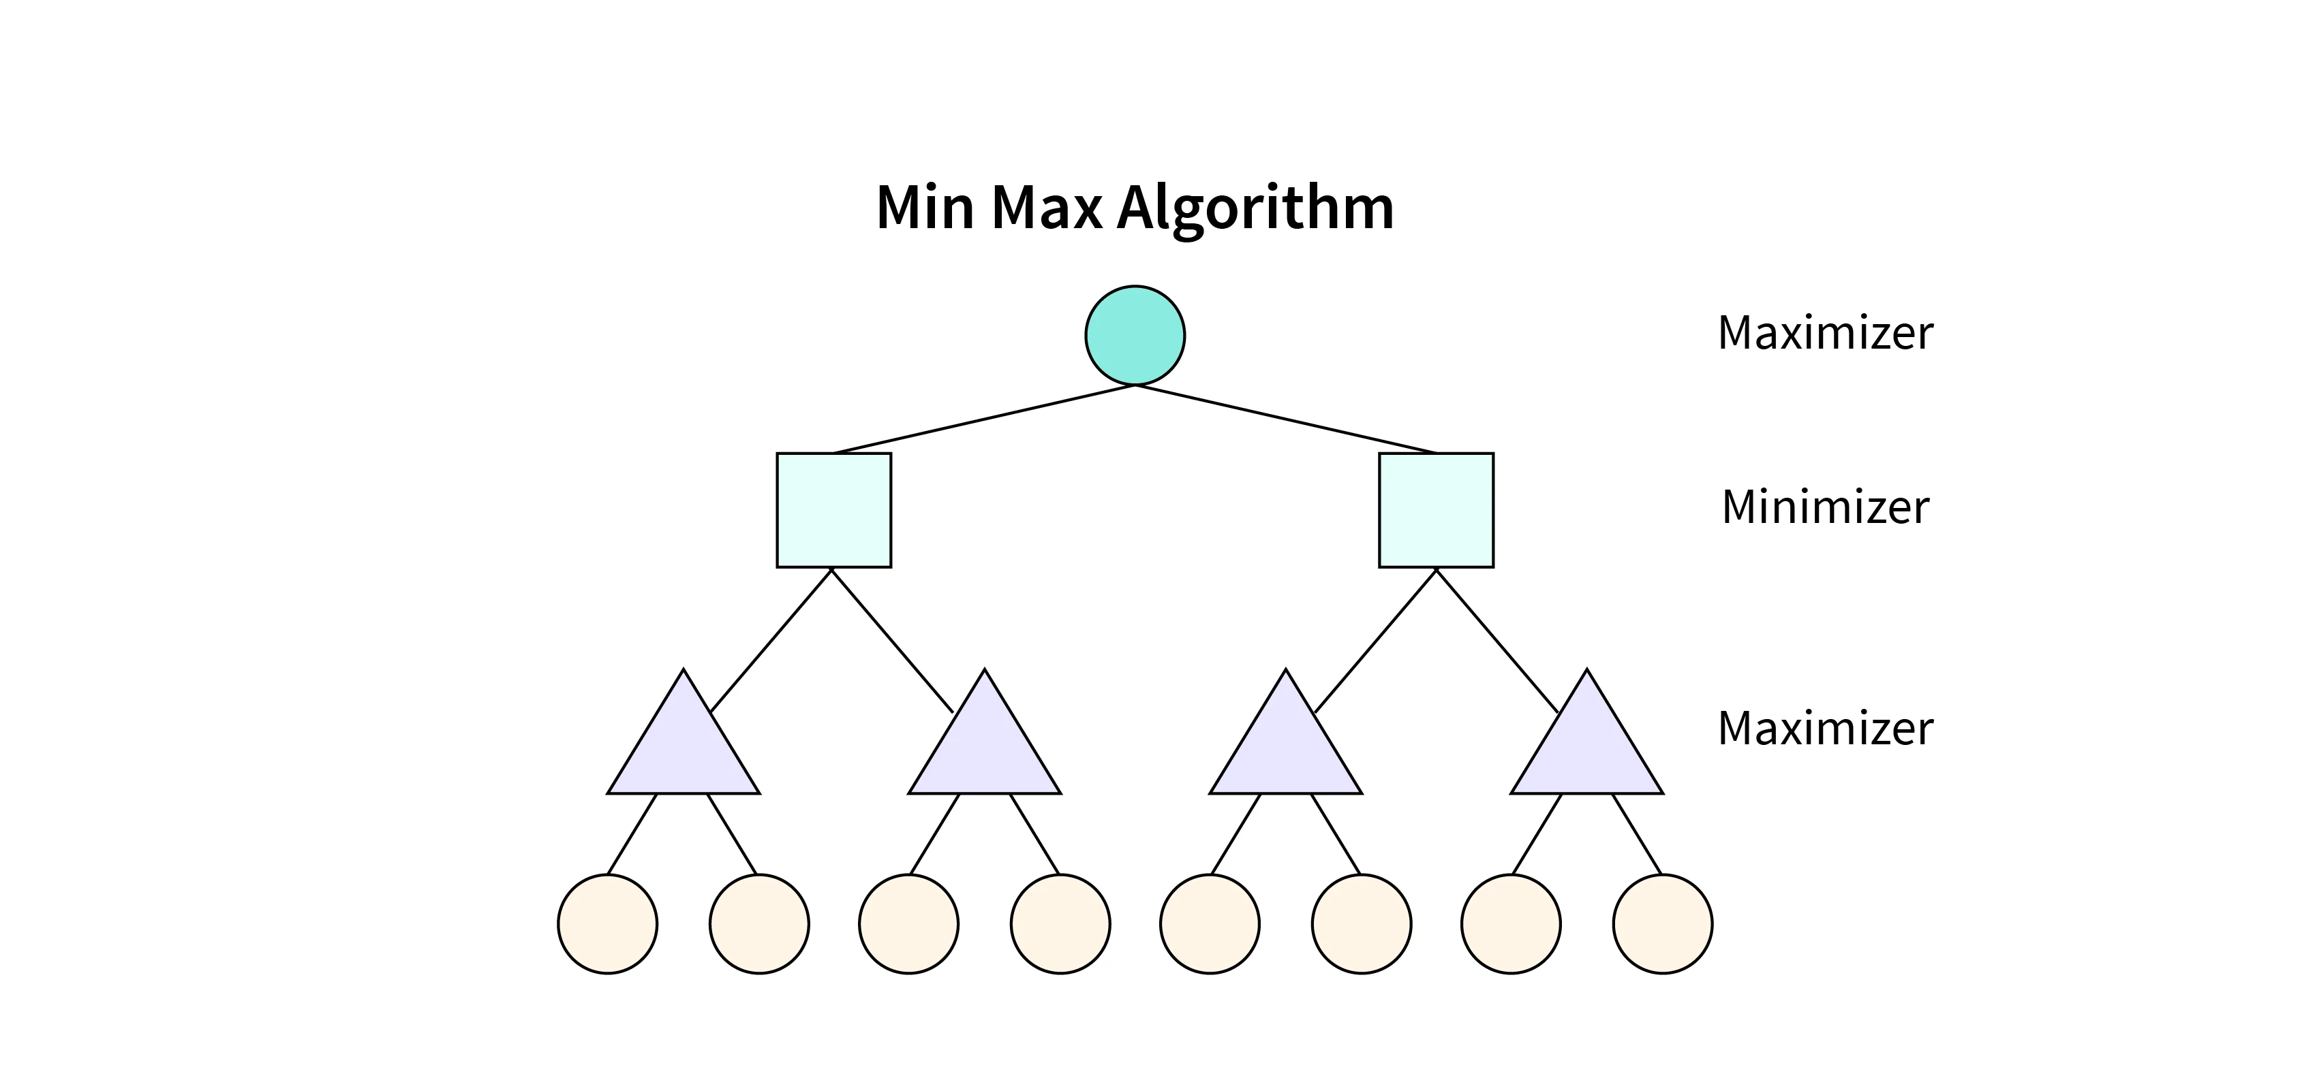

Conclusion:
The Minimax algorithm is a foundational algorithm in artificial intelligence for game playing, providing a systematic way to explore potential game states and make optimal decisions. While it works well for simple games like Tic-Tac-Toe, its efficiency can be greatly enhanced with techniques like Alpha-Beta Pruning. In this assignment, the implementation of Minimax demonstrates its applicability in determining the best moves in competitive two-player scenarios.

